Manuscript Template for the International Journal of Marine Science and Technology

First A. Author*, Second B. Author, and Third C. Author
Abstract: This article outlines the preparation procedure for publication in the International Journal of Marine Science and Technology (IJMST). This template is applicable for both the initial submission and the final camera-ready manuscript. Authors must adhere to these instructions when submitting their work for review. The abstract should be between 200 and 1000 characters in length. Please prevent citing references and minimize the use of abbreviations and in the abstract.

Keywords: At least four keywords or phrases in alphabetical order, separated by commas.

1. INTRODUCTION
Manuscript received April 15, 2025; received in revised form May 25, 2025; accepted June 20, 2025; available online July 9, 2025.

First A. Author is with the Department of Mechanical Engineering, Vietnam Maritime University, Haiphong, Vietnam (e-mail: author@vimaru.edu.vn). Second B. Author and Third C. Author are with the School of Electrical Engineering, Korea University, Seoul 02841, Korea (e-mails: dliu@xidian.edu.cn, hironaka@korea.ac.kr).
* Corresponding author.

Please use the Microsoft Word template to prepare your manuscript. You can download this file from https://i-jmst.vimaru.edu.vn/.
Submitting the manuscript in a two-column format using the template is highly recommended. Authors must strictly adhere to these guidelines to maintain the journal’s standards.
A manuscript is divided into three parts: The first part contains the title, authors’ names, abstract, and keywords. The second part is the main body of the article, which includes the conclusion section. The third part is the authors’ profile section at the end.

2. ARTICLE SIZE AND FORMAT

The article size should be A4, with the following margins applied:
Left margin | 20 mm
Right margin | 20 mm
Top margin | 30 mm
Bottom margin | 30 mm
Heading | 10 mm
The maximum length for a double-column article is 8 pages.
3. FONTS AND STYLE

3.1. First part
The first section should contain the article title, authors’ names, abstract, and keywords. All text must use Times New Roman font. The font sizes are as follows: title—14 pt (bold), authors’ names—10 pt (bold), abstract—10 pt, and keywords—10 pt.

3.2. Article body
The second part of the manuscript’s main body should be formatted in double columns, with each column 80 mm wide and separated by 8 mm. The top-level heading, typically called a section and numbered in Roman numerals, must appear centered in the column using Times New Roman, bold, all capitals, 10 pt. Numbered level-two headings should be in Times New Roman, 10 pt font.
The main text should use Times New Roman, 10 pt, with single line spacing. Each new paragraph begins with a 3.5 mm indentation. However, if there is a blank line before a new paragraph, the indentation may be omitted.
If you press the return key after entering an equation number, the computer interprets this as the start of a new paragraph, which is not intended. Therefore, you must remove the automatic indentation that appears after pressing the return key.

3.3. Subsection
The numbering of the subsection should follow the format shown above.

4. FIGURE / TABLE / EQUATION

4.1. Figure
Clear original figures should be used and arranged at either the top or bottom of each page. Authors should submit the original graphic files separately, along with the main article file, for the camera-ready version after acceptance. Preferred formats for graphics are Tagged Image File (.tif), Encapsulated Postscript (.eps), and JPEG (.jpg). High-contrast line figures should be prepared at 600 dpi resolution, while color or grayscale figures should be prepared at more than 300 dpi resolution. Color figures should remain distinguishable even when printed on black and white printers.

4.2. Table
Like figures, tables should be placed at the top or bottom of each page.
Table 1. The caption must be shown before the table.
 | System 1 | System 2 | System 3
X
Y
Z

4.3. Equation
Equations should be numbered consecutively throughout the article, with the equation number placed at the far right of the line in parentheses. Equations should be left-aligned within the column. For example:
Theorem 1: Consider a Lyapunov candidate
(1)
where, s is avector of sliding surface.
Proof: Each equation should be separated by a comma. Assuming the Equation Editor is used, the recommended font size settings are as follows:
Main equation: 10 pt (Times New Roman),
Subscript/superscript: 7 pt (Times New Roman),
Sub-subscript: 6 pt (Times New Roman),
Symbol: 150%,
Sub-symbol: 100%.

Remark 1: The journal office knows how to convert all equations into font 10 pt at once. Please inquire about this before preparing the final manuscript. This will be handy for you.

4.4. Equation/figure/table citation
Equation (1) indicates a Lyapunov function. Fig. 1 is the first figure. Table 1 is cited as such. In the article, all authors are required to use the SI unit.
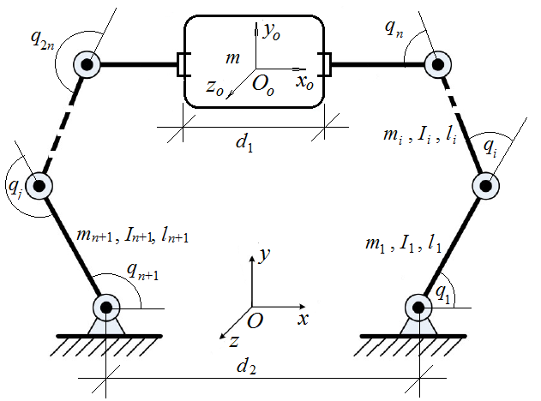
Fig. 1. The caption must be shown after the figure.
4.5. References
References is cited by numerals in square brackets [1,3-5]. Use Times New Roman, 10 pt, for the references [2]. References must be complete and follow the IJMST style as shown in the Reference section of this article. Each reference should include volume, number, pages, and year.

5. CONCLUSION

Authors should prepare their articles for both initial and final submission according to the “Information for Authors” available at https://i-jmst.vimaru.edu.vn/ and in this file. If accepted, authors will be required to submit the final version of their manuscript to the journal office.

APPENDIX A

The author(s) may include an appendix with a relevant title here.

DECLARATIONS

Conflict of Interest
The authors declare that there is no competing financial interest or personal relationship that could have appeared to influence the work reported in this article.

Authors’ Contributions
First Author: Conceptualization, Investigation, Writing - Original Draft. Second Author: Investigation, Writing - Review & Editing. Second Author: Conceptualization, Supervision.

Funding
This work was supported by the Vietnam Maritime University under Grant ABC-XYZ.

REFERENCES

- X. Liu, Z. Ren, H. Lyu, Z. Jiang, P. Ren, and B. Chen, “Linear and nonlinear regression-based maximum correntropy extended Kalman filtering,” IEEE Transactions on Systems, Man, and Cybernetics, vol. 51, no. 5, pp. 3093-3102, 2021.
- C. Hoffmann and H.Werner, “A survey of linear parameter varying control applications validated by experiments or high-fidelity simulations,” IEEE Transactions on Control Systems Technology, vol. 23, no. 2, pp. 416-433, 2015.
- Z. Yin, N. Zhang, X. He, and others, “Sampled-data control for linear systems via a looped functional method,” Proc. of 9th International Conference on Control Science and Systems Engineering, IEEE, pp. 344-348, 2023.
- K. Ogata, Modern Control Engineering, 5th ed., Prentice Hall, 2010.

