Probabilistic Forecasting of Project Cost and Schedule Using Earned Value Management and Monte Carlo Simulation

Kim Son Luong and Nhu Son Doan*
Abstract: Accurate forecasting of project cost and schedule is essential for effective project control and decision-making. Traditional earned value management (EVM) offers a deterministic view of performance but fails to capture the uncertainties inherent in dynamic project environments. This study introduces a probabilistic forecasting approach that integrates EVM with Monte Carlo simulation to model the stochastic behavior of cost and schedule performance indices. Two hypothetical project scenarios are analyzed to demonstrate the method’s applicability: one characterized by cost efficiency but schedule delay, and another by schedule progress but cost overrun. In both cases, cumulative project data—planned value, earned value, and actual cost—are used to generate probabilistic estimates of cost and duration at completion, along with confidence intervals and risk profiles. The results show that the proposed framework produces smoother and more credible forecasts while quantifying the likelihood of budget and schedule outcomes. This enhances the interpretability and reliability of EVM by linking performance trends with uncertainty, offering project managers deeper insights for proactive and risk-informed decision-making.

Keywords: Earned value management, Monte Carlo simulation, project cost and schedule control, project performance forecasting.

1. INTRODUCTION
Manuscript received October 31, 2025; received in revised form December 10, 2025; accepted December 11, 2025; available online December 30, 2025.

Kim Son Luong is an engineer at Phu Xuan Construction and Consulting JSC, Vietnam. Nhu Son Doan is with the Faculty of Civil Engineering, Vietnam Maritime University, Haiphong, Vietnam (e-mails: vanson.ctt@vimaru.edu.vn).
* Corresponding author.

Accurate forecasting of project cost and completion time is a critical requirement for effective planning, decision-making, and risk mitigation throughout a project’s life cycle. In practice, construction and engineering projects face numerous sources of uncertainty—such as fluctuating productivity, scope changes, estimation errors, and market risks—that make purely deterministic forecasting methods less reliable. Among the established approaches, the earned value management (EVM) has been widely adopted as an integrated tool to monitor cost and schedule performance through metrics such as the earned value (EV), planned value (PV), actual cost (AC), the cost performance index (CPI), the schedule performance index (SPI), and forecasts such as estimate at completion (EAC). EVM is regarded as a standard framework for project control in many organizations (Anbari, 2003).
Building on this foundation, various extensions have been developed to improve the predictive capability of EVM. For instance, the earned schedule has been proposed to address some of the shortcomings of SPI in schedule prediction. These efforts highlight that while EVM is a powerful tool for performance tracking and trend detection, its forecasting ability remains limited under complex or dynamic conditions (W. Lipke, 2012).
The traditional form of EVM exhibits several notable weaknesses when applied to forecasting. Most importantly, it relies on a deterministic approach: indicators such as CPI and SPI are used directly as adjustment factors for EAC or estimated duration (ED) forecasts under the implicit assumption that future performance exactly mirrors past performance. This assumption can produce significant bias if performance trends shift over time or if only limited progress data are available at early stages. Empirical assessments also show that classical and extended EVM techniques often deliver uneven accuracy across project types and phases, particularly in high-uncertainty environments or when input variability is underestimated (Chen et al., 2016).
To address these limitations, recent research and practice have moved toward combining EVM with probabilistic methods—notably Monte Carlo Simulation (MCS) and related risk-analysis techniques (Acebes et al., 2015; Bonato et al., 2019; Duc, 2025; Vargas, 2004). By modeling input variables (e.g., unit costs, productivity rates, activity durations) as random variables with specified probability distributions, MCS generates a range of possible outcomes rather than a single-point estimate. This approach enables the derivation of confidence intervals, exceedance probabilities, and sensitivity analyses for key performance indicators, thereby providing richer information to support proactive project management.
This study introduces an alternative probabilistic EVM framework that integrates traditional EVM metrics with MCS to generate distribution-based forecasts of project cost and duration. Two illustrative case studies with hypothetical data are used to demonstrate the approach. The proposed approach offers a more realistic and transparent assessment of project performance than classical EVM, enhancing managers’ ability to anticipate overruns and devise timely mitigation strategies.

2. METHODS

This section presents the methodological framework for developing and evaluating the probabilistic EVM–MCS approach for project cost and schedule forecasting. Section 2.1 introduces the synthetic datasets and reporting structure. Section 2.2 summarizes conventional deterministic EVM metrics as the baseline. Section 2.3 explains the uncertainty modeling and parameter estimation. Section 2.4 describes the MCS and validation procedures, and Section 2.5 outlines the sensitivity and scenario analyses used to examine the influence of model parameters on forecast outcomes.

2.1. Data and context
In this study, two hypothetical project datasets are developed to demonstrate the proposed probabilistic EVM framework. Both datasets mimic typical project reporting structures. For each reporting period, the PV, EV, and AC are generated to reflect realistic project progress patterns and performance fluctuations.
The first example represents a project that remains under budget but experiences schedule delays, whereas the second illustrates a case of cost overrun despite schedule progress being generally maintained. These contrasting conditions enable evaluation of the framework’s capability to handle diverse performance dynamics. The approach and data structure adopted here are compatible with actual project reporting systems, allowing future applications to extend directly to real project datasets once sufficient historical EV, PV, and AC records are available.
To improve parameter estimation and avoid early‐stage bias, we divide the project’s execution into a warm‐up period (initial reporting periods) and the main forecasting period. The warm‐up period is used to estimate statistical properties (e.g., mean, variance, autocorrelation) of performance indices (CPI, SPI) and cost/time growth behavior. Only after this warm‐up period we implement forecasting, using observed data up to each status date.

2.2. EVM metrics and deterministic forecasts
Traditional EVM metrics are used as the starting point for baseline forecasts. The cost performance index and schedule performance index are defined in Eqs. (1) and (2), respectively.
(1)
(2)
Forecasts of the final cost at completion can be produced using standard formulas such as the CPI-only estimate at completion, the CPI×SPI composite, or other variants, as shown in Eqs. (3) and (4) (Anbari, 2003):
(3)
(4)
Where BAC is the budget at completion. The estimate to complete (ETC) and variance at completion (VAC) are then calculated by Eqs. (5) and (6).
(5)
(6)
Optionally, the earned schedule technique can be incorporated to improve time forecasting by translating earned value into time-based metrics (W. H. Lipke, 2003). These deterministic indicators form the baseline against which probabilistic forecasts are compared.

2.3. Uncertainty Modeling
While deterministic EVM metrics are widely used in practice, their point forecasts provide no information about the range of possible outcomes or the likelihood of overruns. To address this limitation, key EVM variables are treated as random variables whose distributions can be estimated from historical data. Candidate stochastic drivers include the time-varying (t) CPI_{t} and SPI_{t}, the incremental growth of EV between reporting periods, the variance of AC, and the amount of schedule slippage recorded in each period.
Each random driver is assigned an appropriate probability distribution. For example, CPI and SPI can often be modeled as lognormal or normal variables due to their positive and skewed nature, whereas bootstrapping historical observations can be used as a nonparametric alternative when sample sizes are small or distributional assumptions are uncertain. Goodness-of-fit tests such as Kolmogorov–Smirnov (Stephens, 1986) are applied to check the plausibility of the chosen distributions. In this work, to estimate the parameters of these distributions, the Maximum Likelihood Estimation (MLE) method is applied, as it provides consistent and efficient estimates by maximizing the likelihood of observing the given sample (Pawitan, 2001).
Because cost and schedule performance often move together, the correlation between CPI and SPI is estimated from historical data—typically using Pearson’s correlation coefficient ρ—and incorporated into a multivariate sampling procedure (Vanhoucke, 2012). This approach ensures that simulated cost and schedule trajectories reflect the real-world interdependence of performance indices.

2.4. Monte Carlo Simulation
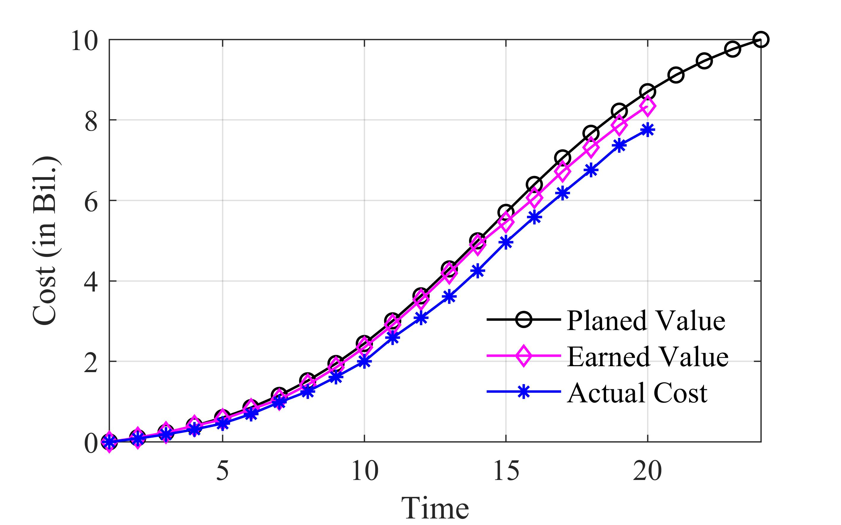

Fig. 1. Ex. 1 - Delayed but under-budget project.

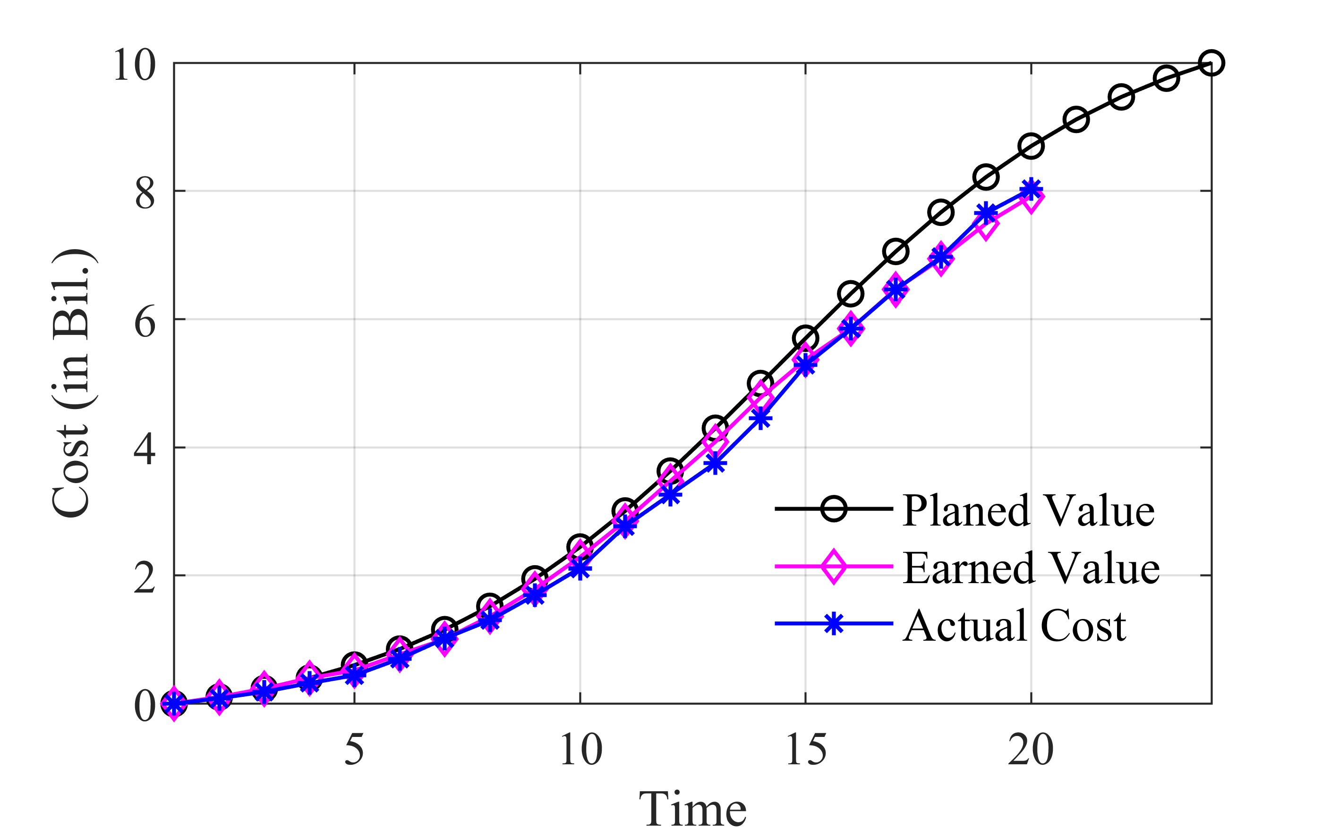

Fig. 2. Ex. 2 – Behind-schedule and over-budget project.
The core of the proposed method is a MCS pipeline that converts the estimated distributions and correlations into a full forecast distribution of final project outcomes. The process consists of three main steps:
Step 1: Sampling correlated performance indices. In each iteration of the simulation, a vector of stochastic drivers—(CPI_{t}, SPI_{t})—is drawn from the fitted multivariate distribution, accounting for their correlations.
Step 2: Projecting cost and schedule trajectories. The sampled values are applied to update the project’s cost and progress trajectory forward from the current period until completion. This produces one simulated path of EAC and ED under the derived stochastic behavior.
Step 3: Aggregating forecast distributions. For a large number of samples (e.g., 200,000), the empirical distributions of EAC and ED are constructed. From these, the model extracts percentiles such as P50 and P80 forecasts and calculates the probability of meeting cost and schedule targets (i.e, ≤ Budget, ≤ Deadline). Convergence of the simulation is monitored by tracking the stability of quantiles across iterations.
This pipeline transforms the traditional single-point EVM forecast into a probability distribution, enabling decision-makers to gauge not only expected outcomes but also the likelihood of adverse scenarios.
To evaluate predictive accuracy, the model is calibrated and validated using a rolling-origin backtesting procedure. At each reporting period t, the model generates probabilistic forecasts (P50, P80, full distribution) of EAC and ED, which are then compared to the realized outcomes once additional data become available.
Forecast accuracy is assessed using several complementary metrics. Mean absolute error (MAE) and mean absolute percentage error (MAPE) quantify the deviation of point forecasts from realized outcomes. Calibration of probabilistic forecasts is evaluated through probability integral transform histograms, Brier scores, and the empirical coverage of prediction intervals (Gneiting & Raftery, 2007). These diagnostics ensure that the model is not only accurate on average but also well-calibrated in its uncertainty estimates.

2.5. Sensitivity and Scenario Analysis
Finally, sensitivity analyses are conducted to examine how changes in model assumptions and parameters affect forecast results. Tornado diagrams display the relative influence of input parameters such as the correlation coefficient ρ(CPI, SPI), the standard deviations of CPI and SPI on the resulting EAC/ED distributions. In this study, the sensitivity analysis focuses on quantifying how ±25% variations in the correlation coefficient ρ(CPI, SPI) and the variances of CPI and SPI affect the probabilistic forecasts of EAC at the 80th percentile. This provides practical insights into which parameters most strongly influence the reliability of project cost predictions.

3. ILLUSTRATIVE EXAMPLES

This section presents two illustrative examples to demonstrate the application of EVM analyses. In both cases, the PV, EV, and AC curves are examined over the project timeline. The PV is defined at 24 discrete time points, while the EV and AC are recorded at 20 time points, corresponding to the actual project updates. The project baseline assumes a budget at completion (BAC) of 10 billion. The examples are used to highlight how different project performance scenarios can be interpreted through EVM metrics, considering both deterministic and probabilistic perspectives. Particularly, Ex. 1 represents a project that is delayed but remains under budget, while Ex. 2 illustrates a project that is simultaneously behind schedule and over budget.

3.1. Example 1 – a delayed but under-budget project
Fig. 1 illustrates a project whose performance consistently shows delays in progress while maintaining cost savings. The EV curve remains below the PV, indicating that the actual work accomplished is less than scheduled. At the same time, the AC curve stays below the EV, suggesting that the project spends less than the value of the work completed. This situation represents a case of behind schedule but under budget, where the project is not progressing as planned but achieves cost efficiency.

3.2. Example 2 – a behind-schedule and over-budget project

Fig. 2 presents a contrasting case with Fig. 1, where the project suffers from both schedule delays and cost overruns. The EV curve again falls below the PV, reflecting late progress compared to the baseline plan. Unlike Ex. 1, however, the AC curve lies above the EV at the current time (t=20), showing that actual spending currently exceeds the earned value. This situation corresponds to a behind-schedule and over-budget project, considered the most unfavorable outcome in project performance management.
This section presents and discusses the results obtained from the two illustrative examples, with the analysis covering evaluation periods from 6 to 20. The discussion is organized into three parts. First, the estimated costs at completion derived from deterministic and probabilistic approaches are compared to highlight their differences in stability and reliability. Second, the probabilities of completing the project under budget and ahead of schedule are evaluated to capture the likelihood of achieving key performance objectives under uncertainty. Finally, a sensitivity analysis is conducted to identify the main drivers of forecast variability and to assess how uncertainties in performance indices influence the upper-tail outcomes of the probabilistic estimates.
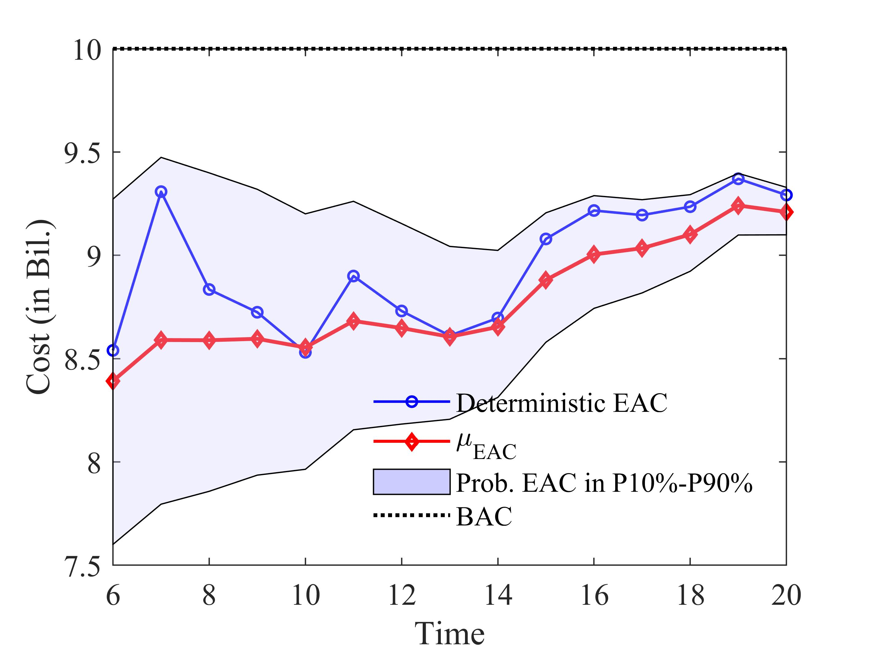
(a)
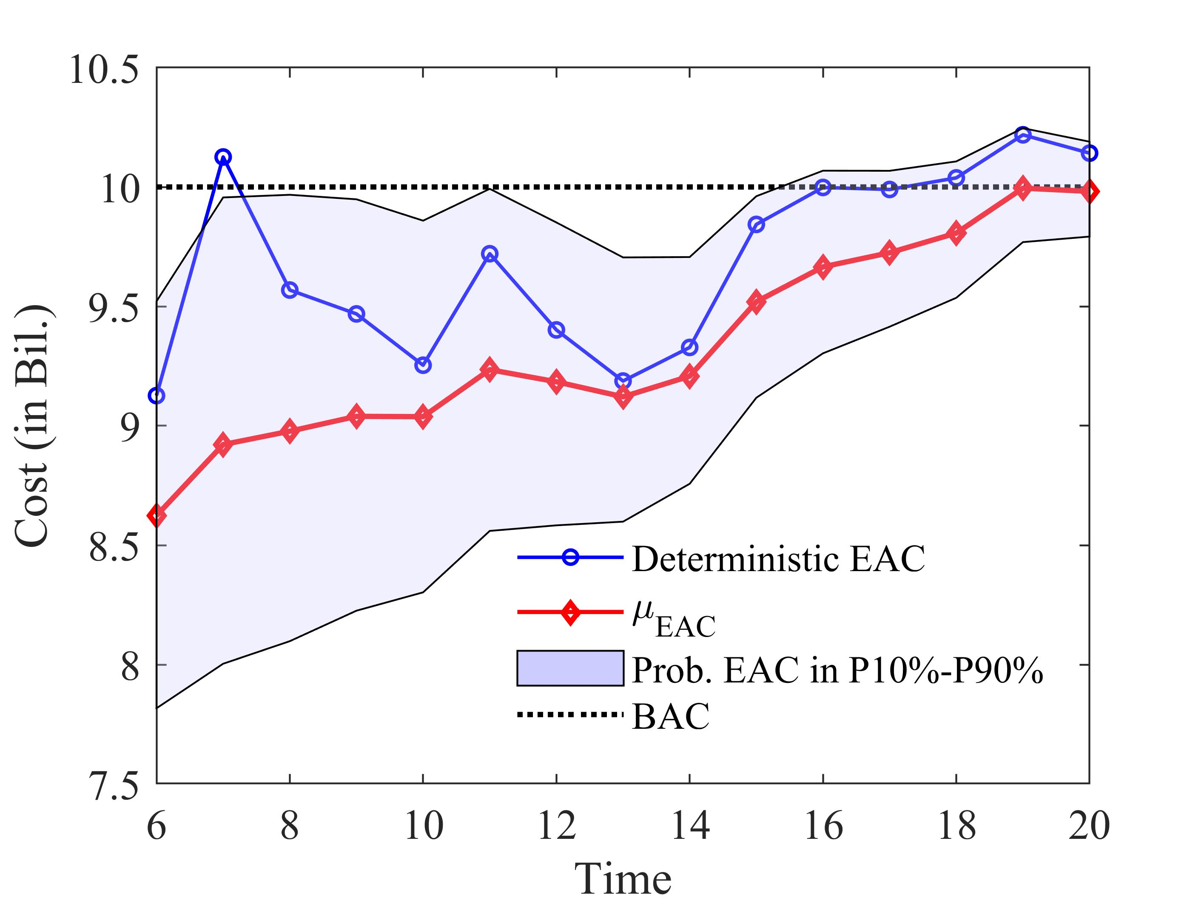
(b)

Fig. 3. Deterministic and probabilistic EAC forecasts: a, for Ex 1; and b, for Ex 2.

4. RESULTS AND DISCUSSION

This section presents and discusses the results obtained from the two illustrative examples, with the analysis covering evaluation periods from 6 to 20. The discussion is organized into three parts. First, the estimated costs at completion derived from deterministic and probabilistic approaches are compared to highlight their differences in stability and reliability. Second, the probabilities of completing the project under budget and ahead of schedule are evaluated to capture the likelihood of achieving key performance objectives under uncertainty. Finally, a sensitivity analysis is conducted to identify the main drivers of forecast variability and to assess how uncertainties in performance indices influence the upper-tail outcomes of the probabilistic estimates.

4.1. Comparison between the deterministic and probabilistic estimations for the two examples
Fig. 3 presents the estimated EAC for the two examples, obtained using both deterministic and probabilistic approaches over evaluation periods 6 to 20. These results provide an opportunity to examine how project performance conditions, reflected in the PV–EV–AC trajectories, influence the stability and reliability of EAC forecasts.
The deterministic EVM method estimates EAC by extrapolating the observed cost and schedule performance indices (CPI, SPI) at each reporting period. As shown by the blue curves in Fig. 3, these estimates fluctuate considerably because they depend solely on snapshot data from the current period. Short-term variations in CPI or SPI can cause large swings above or below the BAC, resulting in unstable forecasts (Fig. 3(b)). Although simple and computationally efficient, deterministic EAC is highly sensitive to temporary disturbances and thus less reliable for projects with inconsistent performance.
In contrast, the probabilistic approach integrates the cumulative information of PV, EV, and AC from project start to the evaluation period, while explicitly modeling the correlation between CPI and SPI. As illustrated by the red curves (μ_{EAC}, i.e., the mean of estimation) in Fig. 3, probabilistic forecasts are smoother and more consistent, with prediction intervals (P10–P90) that represent plausible cost outcomes. This method provides not only an expected EAC but also the probability of deviation, enabling managers to understand both the central forecast and its uncertainty. Consequently, the probabilistic framework supports more informed and risk-aware decision-making than the deterministic alternative.
In Ex. 1 (Fig. 1), the project consistently shows delays in progress (EV < PV) but spends less than the value of work accomplished (AC < EV). This situation represents a project behind schedule but under budget. The deterministic EAC, although fluctuating, tends to remain below the BAC, reflecting the persistent cost savings observed in the AC curve. The probabilistic analysis supports this assessment, with the mean μ_{EAC} staying below BAC and the prediction interval remaining relatively narrow. The narrowness of the band reflects the stability of cost performance, as the project consistently spends less than expected, even though schedule progress lags.
In Ex. 2 (Fig. 2), the project suffers from both schedule delays (EV < PV) and cost overruns (AC > EV) in several last periods. The unfavorable performance leads the deterministic EAC to frequently overshoot the BAC, particularly at later periods. The strong oscillations underscore how sensitive deterministic forecasts are to unstable cost performance, which reflects the fact that the AC curve does not always lie above the EV. The probabilistic approach, however, leverages accumulated information from the entire project history and incorporates the correlation between CPI and SPI. Consequently, the mean probabilistic forecast remains closer to the BAC at the 20th period, with more than fifty percent chance of being lower. This outcome highlights the stabilizing effect of using historical performance trends: instead of projecting large cost overruns based only on short-term inefficiencies, the probabilistic method balances past and current information to yield a more realistic and credible forecast.
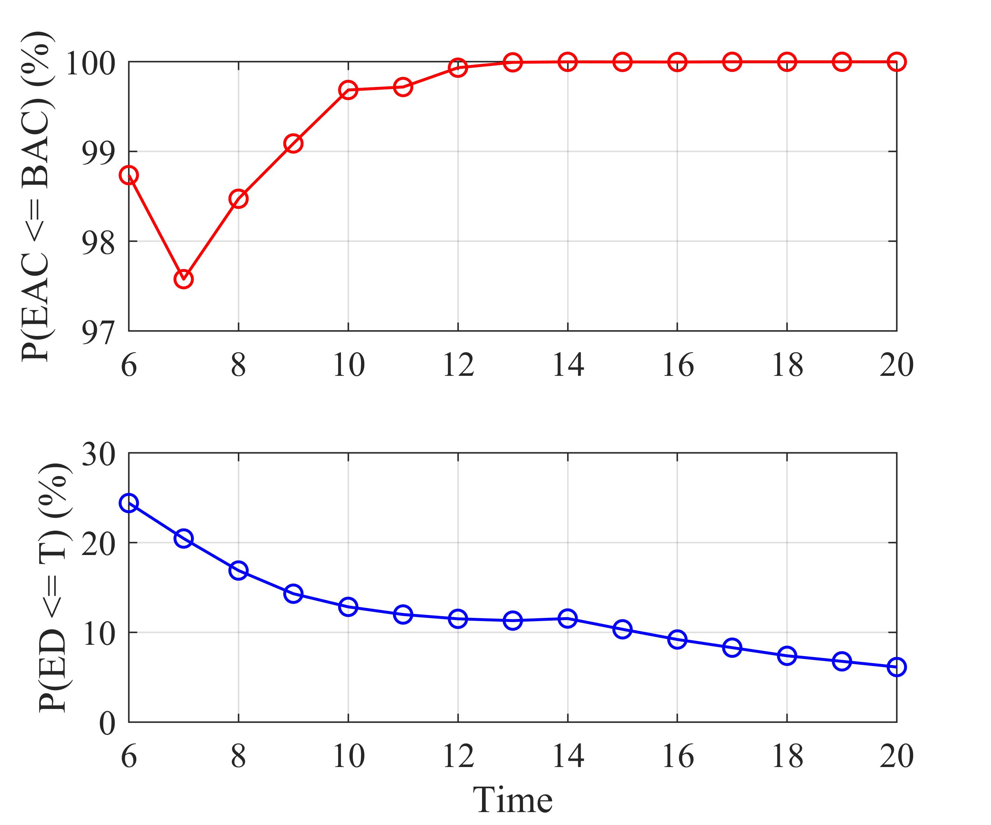
(a)
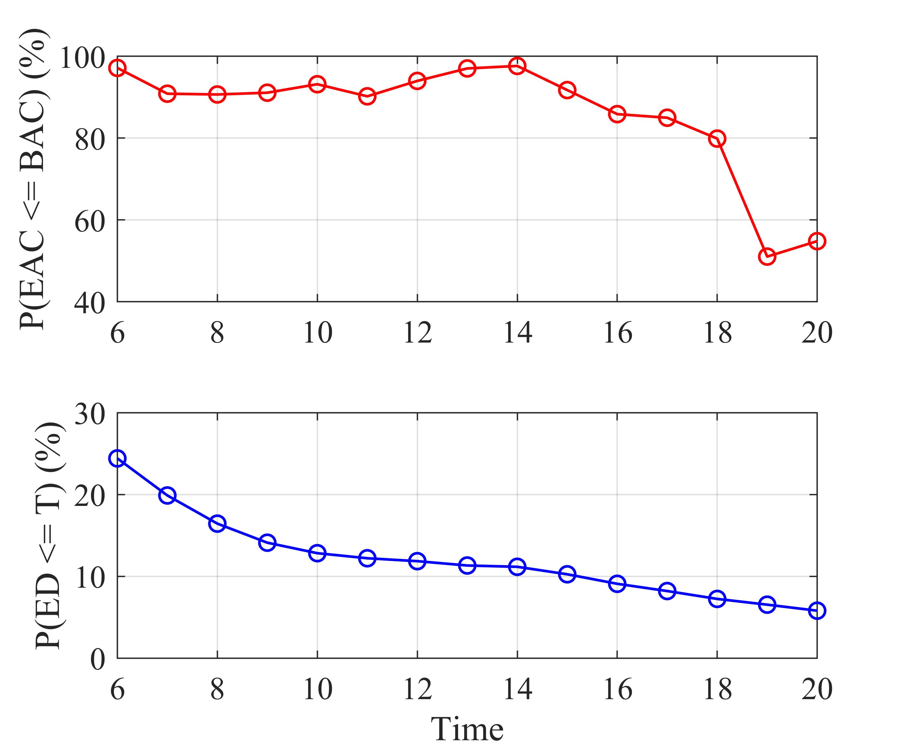
(b)
Fig. 4. Probability of under budget and ahead of schedule.
Taken together, these results emphasize the trade-off between the two methods. The deterministic approach produces quick, point-based estimates that can be useful for immediate assessments but are prone to instability and overreaction to short-term variations. The probabilistic approach, on the other hand, integrates cumulative project data, considers the joint behavior of CPI and SPI, and provides prediction intervals that quantify risk. As a result, it offers a more comprehensive and stable assessment of likely project outcomes, making it better suited for decision contexts where uncertainty plays a critical role.

4.2. Probability of under budget and ahead of schedule
Since the MCSs generate statistical distributions of project outcomes, they enable direct estimation of the probabilities of cost overruns and schedule delays. In particular, one can compute the probability that the project will be completed within the budget at completion (P(EAC ≤ BAC) in the lower panel) and the probability that the project duration will not exceed the planned schedule(P(ED ≤ T) in the lower panel). These probabilistic indicators provide valuable insights into the likelihood of meeting both budgetary and scheduling targets, thereby complementing the deterministic EVM forecasts.
Fig. 4 illustrates the probabilistic assessment of project outcomes in terms of cost and schedule for the two projects. Specifically, the figure presents the probability of completing the project under budget (P(EAC ≤ BAC) in the lower panel) and the probability of finishing earlier than or on schedule (P(ED ≤ T) in the upper panel). These probabilities are obtained by integrating all observed performance data (PV, EV, AC) up to each evaluation period and accounting for the statistical correlation between the CPI and the SPI.
For Ex. 1 (Fig. 4(a)), the probability of completing the project under budget quickly converges to nearly 100% after the 13th period. This outcome is consistent with the observed relationship among PV, EV, and AC: while the project consistently lags behind schedule (EV < PV), the AC remains lower than the value of work accomplished (AC < EV), as shown in Fig. 1. As a result, the probabilistic analysis indicates near certainty that the final cost will not exceed BAC. On the other hand, the probability of finishing ahead of schedule steadily declines over time, falling below 10% at the 20th period. This trend reflects the persistent gap between EV and PV, which points to chronic schedule delays. Taken together, Ex. 1 highlights a scenario where cost performance is favorable but schedule risk dominates, leading to a high probability of under-budget completion but a very low probability of early delivery.
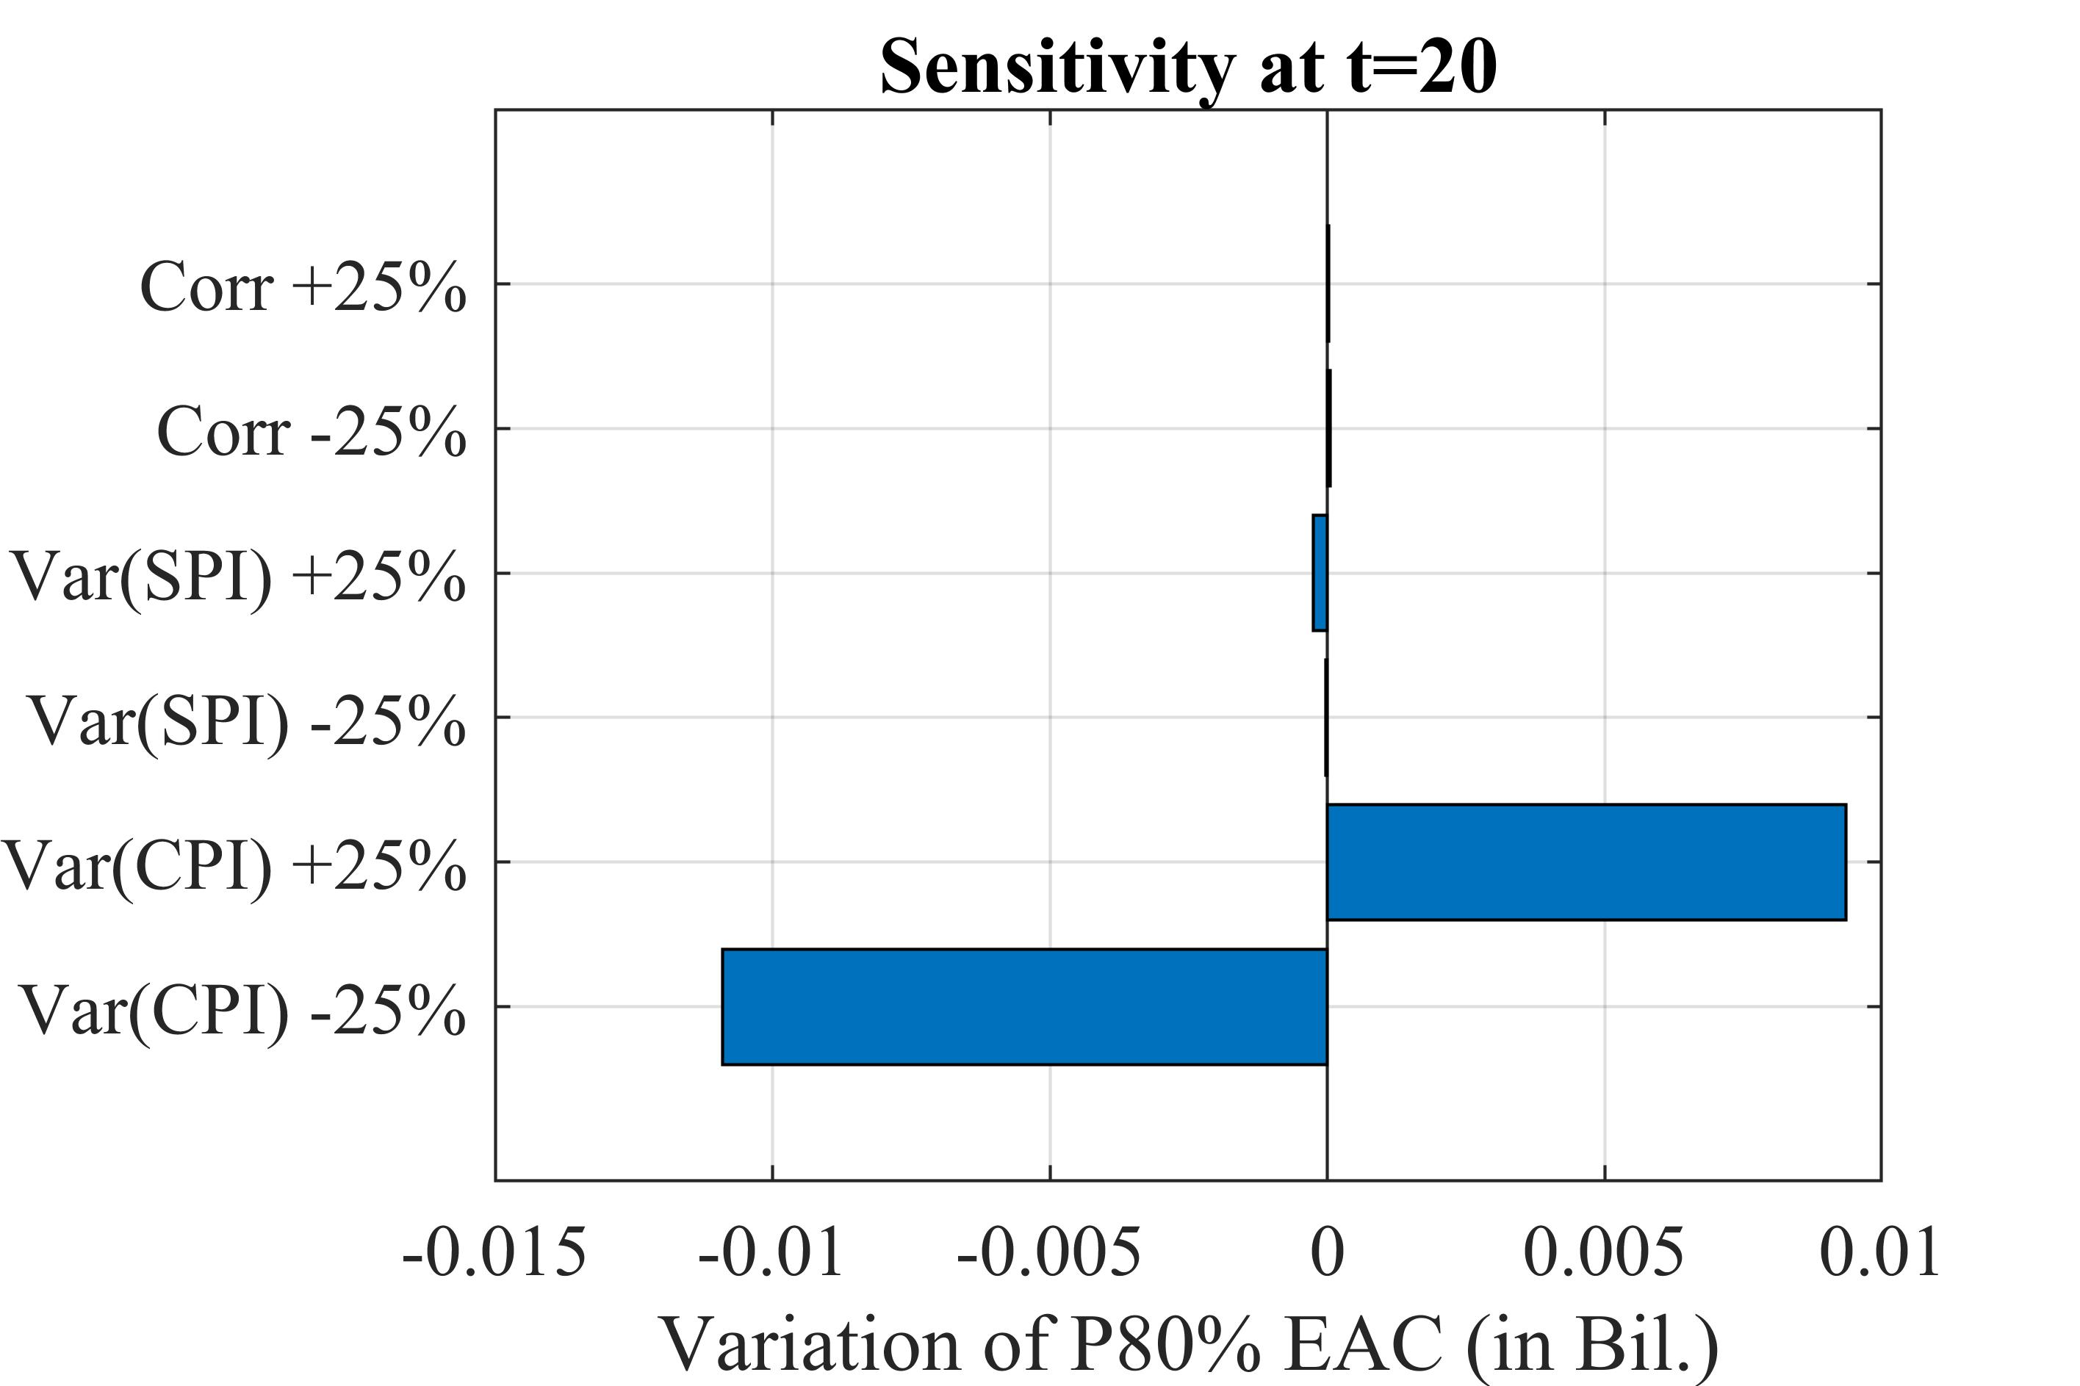
(a)
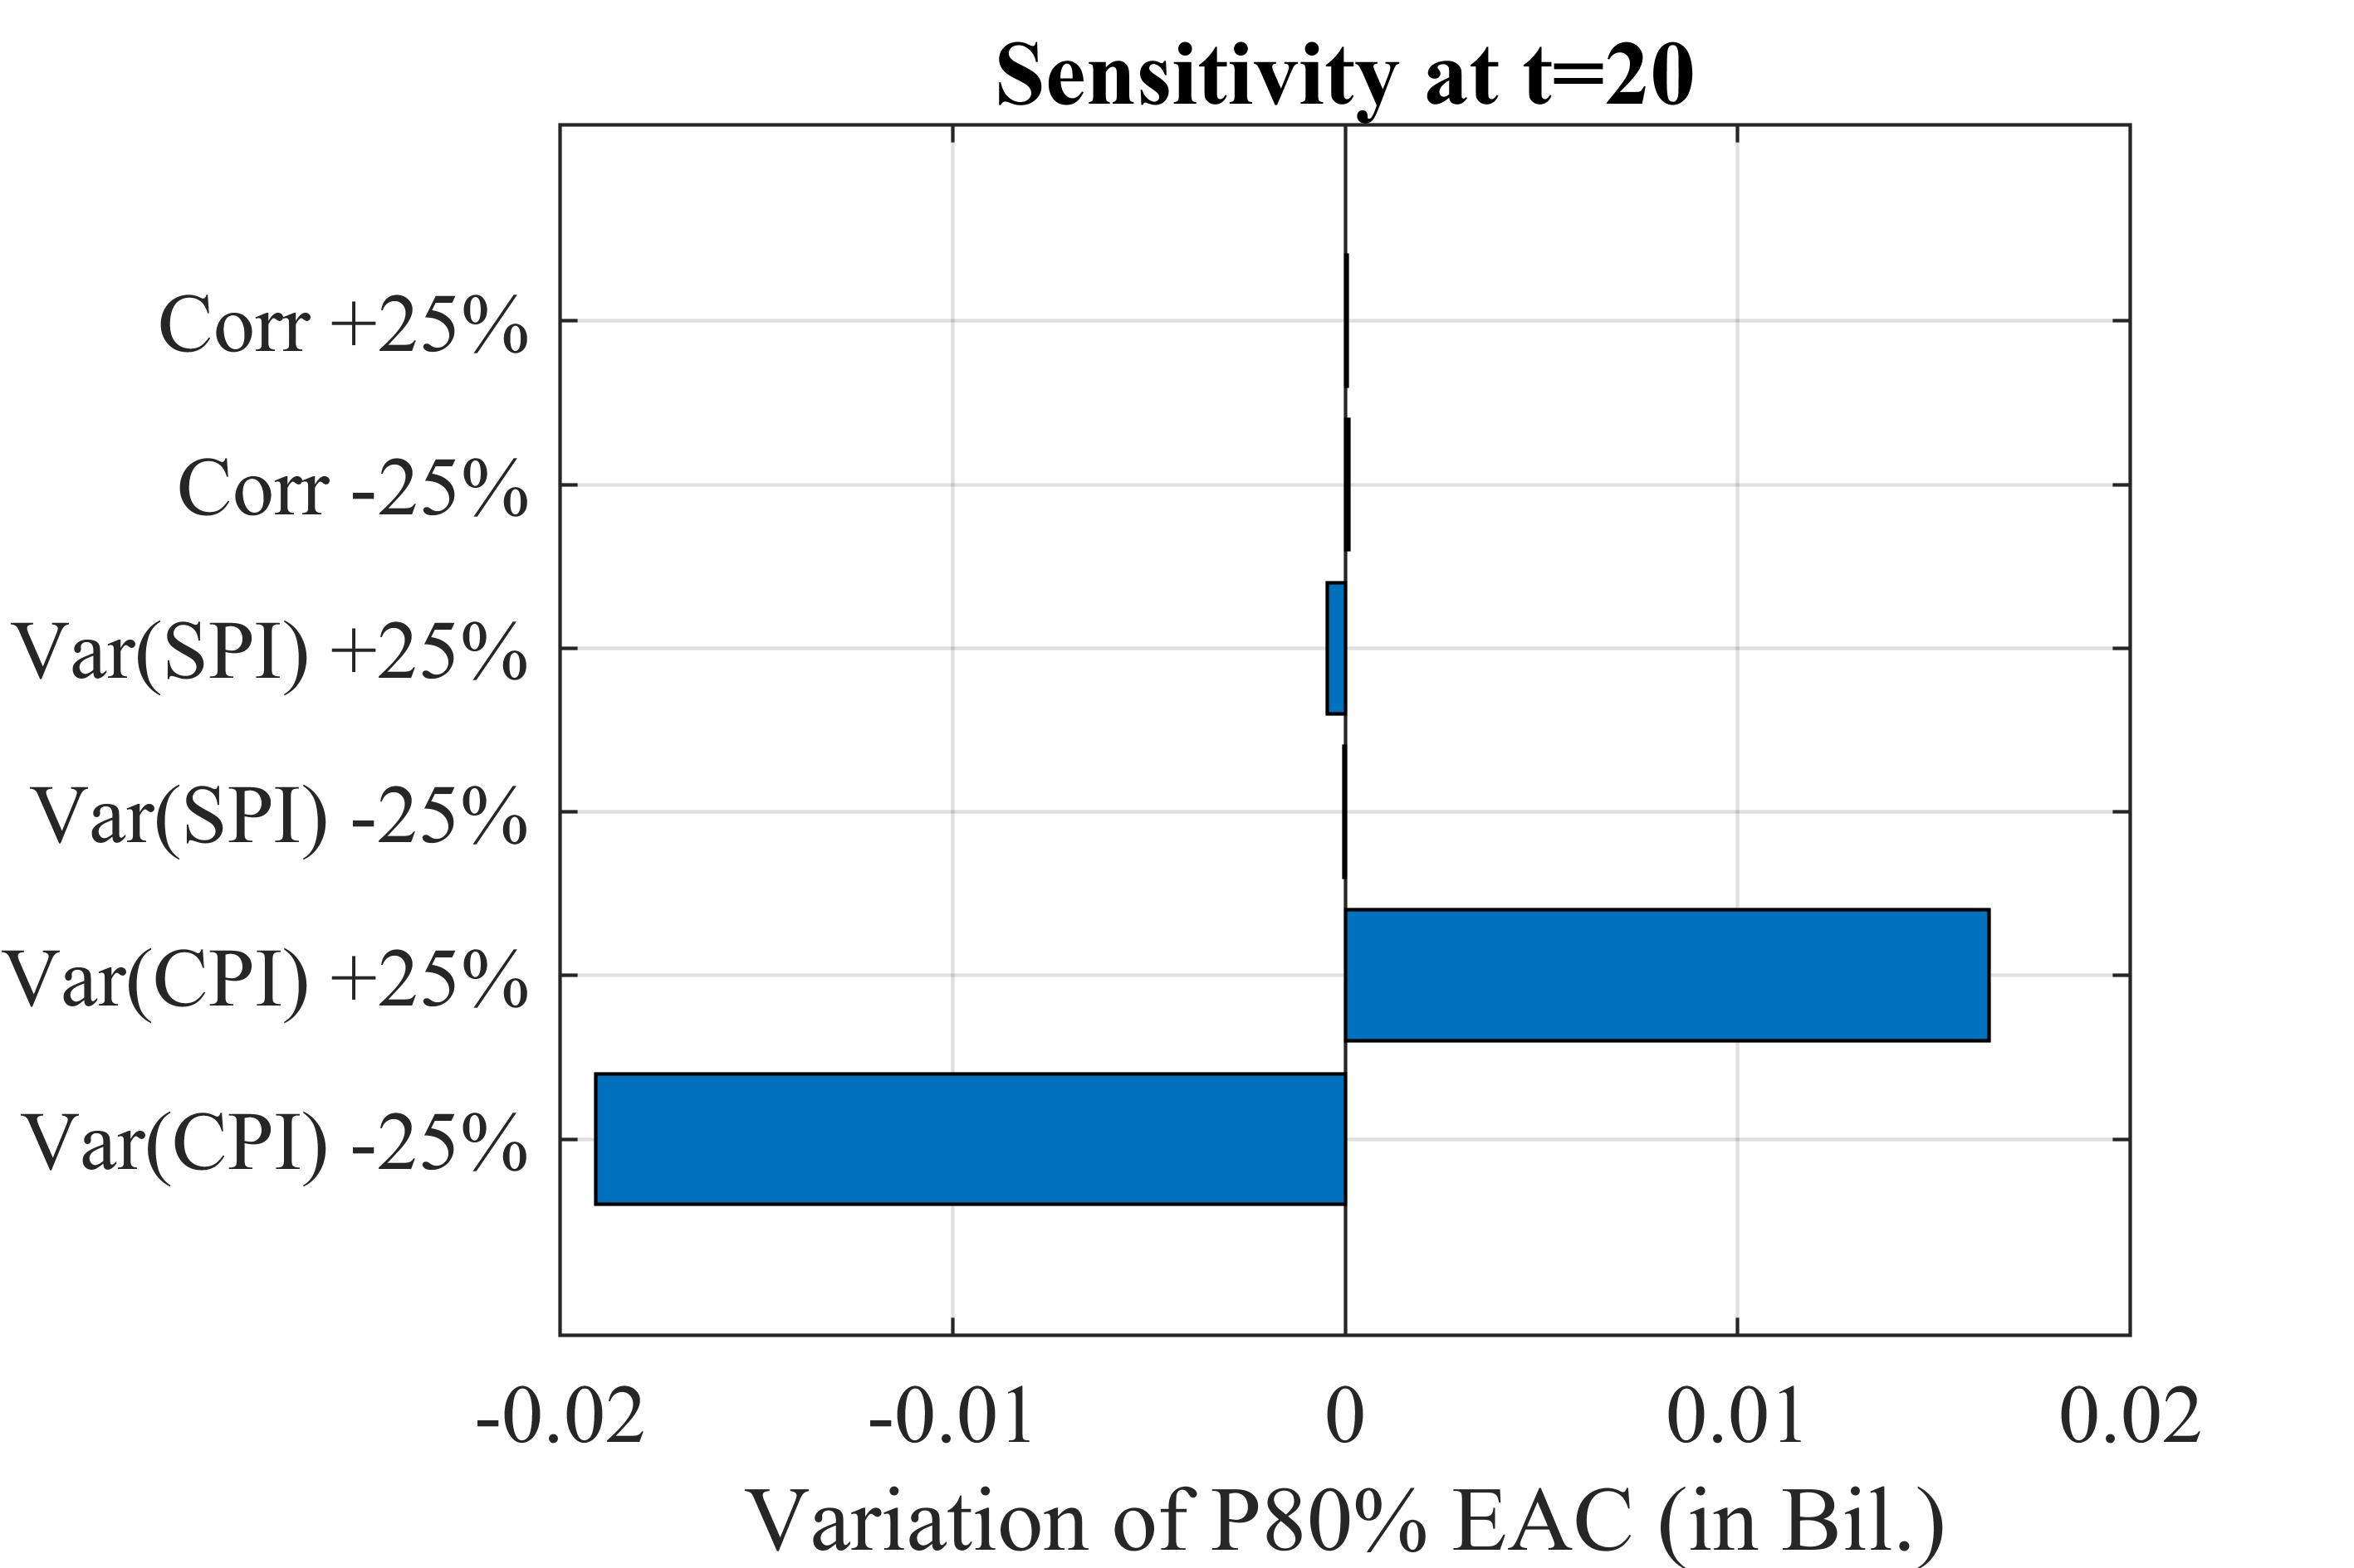
(b)
Fig. 5. Results of sensitivity analysis: (a) for Ex 1; and (b) for Ex. 2.
For Ex. 2 (Fig. 4(b)), the situation is markedly different. Namely, the project simultaneously experiences cost overruns (AC consistently above EV) and schedule delays (EV < PV) at the 19th and 20th periods. As a result, the probability of finishing under budget shows a declining trend for these periods, dropping from near certainty at early stages to around 50% at the current time. This decline captures the worsening cost performance: as the project progresses, cumulative AC increasingly exceeds EV, undermining confidence in meeting the BAC target. In terms of schedule, the probability of completing earlier than planned also decreases gradually, showing a very low level (around 7–8%) at the 20th period. This reflects the compounding effect of delays, as EV persistently trails PV across reporting periods. Unlike Ex. 1, where cost efficiency compensates for delays, Ex. 2 presents an unfavorable situation on both dimensions—cost and time—leading to lower overall project success probabilities.
The comparison between the two examples underscores the value of probabilistic analysis in distinguishing between different project performance patterns. In Ex. 1, deterministic EAC estimates alone might suggest fluctuating outcomes, but probabilistic analysis reveals near certainty of cost savings despite schedule risk. In Ex. 2, although deterministic estimates at later periods predict large overruns, the probabilistic perspective provides a more balanced view, indicating a roughly even chance of staying under budget by the end but very limited opportunity to recover schedule performance.
In summary, probabilistic analysis enables project managers to move beyond point estimates and quantify the likelihood of achieving budget and schedule targets. By integrating cumulative PV, EV, and AC data, it highlights the contrasting nature of cost and schedule risks: projects may be under budget but late (Ex. 1), or simultaneously over budget and late (Ex. 2). These insights are critical for tailoring corrective actions—whether focusing on accelerating progress or tightening cost control—to improve the chances of project success.

4.3. Sensitivity analysis
Sensitivity analysis is conducted to investigate how uncertainties in project performance drivers influence the overall probabilistic outcomes of cost and schedule. By systematically varying key input factors and quantifying their contributions to the variability of project results, sensitivity analysis provides deeper insights into which performance indicators exert the greatest impact on the predicted EAC. This approach complements the MCS–based assessment by highlighting the most influential sources of risk, thereby supporting more effective project control and decision-making.
In this study, the sensitivity results are assessed based on the 80th percentile of the estimated cost at completion (i.e., P80% EAC), which corresponds to a conservative forecast ensuring a high confidence level. The analysis is performed at the current period (t = 20), when sufficient project performance data (CPI and SPI) have been accumulated to provide reliable probabilistic estimates. This setup allows identifying the dominant risk drivers affecting the upper-tail outcomes of project cost forecasts.
Fig. 5 presents the results of the sensitivity analysis for the two illustrative examples, focusing on the effect of ±25% changes in the correlation between CPI and SPI as well as the variances of these indices on the probabilistic estimate of EAC at the 80th percentile. The analysis was conducted using data up to the current period.
For Ex. 1 (Fig. 5(a)), the results show that the variability of CPI exerts a clear influence on the probabilistic cost forecast, though the overall magnitude of this effect is moderate. This outcome is consistent with the project’s performance data up to t = 20: the earned value has tracked relatively closely with the actual cost, and both remain in line with the planned value. Because cost and progress are reasonably aligned, fluctuations in CPI variance introduce changes in the P80 EAC, but these shifts are not dominant. Meanwhile, changes in SPI variance and the correlation coefficient produce almost negligible variations, reflecting the fact that schedule performance up to t = 20 has remained steady and has not substantially driven the forecast.
By contrast, for Ex. 2 (Fig. 5(b)), the impact of CPI variability on the P80 EAC is much stronger (about two times). At t = 20, the project’s EV lags behind PV, while AC continues to accumulate, leading to a cost overrun signal and a less favorable CPI. Under these conditions, the uncertainty in CPI directly amplifies the spread of the forecast distribution: increasing CPI variance by 25% shifts the P80 EAC upward more significantly than in Ex. 1, while reducing CPI variance tightens the estimate. Again, SPI and correlation remain marginal factors, reflecting the lesser role of schedule deviations in shaping the probabilistic cost forecast.

5. CONCLUSION

This study examined the application of probabilistic extensions to earned value management for project performance forecasting. By analyzing two illustrative examples, the results show that probabilistic EVM significantly improves upon deterministic methods by providing more stable, accurate, and risk-aware forecasts. Unlike deterministic estimates, which fluctuate due to reliance on snapshot indices, probabilistic forecasts integrate cumulative project information (PV, EV, AC) and explicitly account for the correlation between CPI and SPI. This yields smoother projections and prediction intervals that can quantify uncertainty in completion costs.
The probability-based analysis highlighted important contrasts between the two examples. In Ex. 1, although the project lagged in schedule (EV < PV), cost efficiency (AC < EV) ensured a near-certain probability of completing under budget but a very low probability of finishing on time. In Ex. 2, the cost performance deteriorated, leading to declining probabilities of success in both dimensions. These results demonstrate the value of probabilistic EVM in distinguishing risk patterns and enabling managers to prioritize corrective actions where they matter most.
Sensitivity analysis further emphasized the role of performance drivers. At t = 20, CPI variability was found to be the dominant factor influencing the upper-tail forecasts of EAC (P80%), particularly in Ex. 2, where cost overruns were not consistent. In Ex. 1, where EV and AC were balanced, CPI variance played only a moderate role, while schedule-related factors were negligible. Overall, probabilistic EVM provides a comprehensive framework that not only forecasts likely outcomes but also identifies uncertainties and their drivers, supporting more informed and resilient project control.
This study is limited by the use of hypothetical data and simplified assumptions, including stable performance indices and constant cost–time correlation, adopted to clearly illustrate the proposed methodology. In practice, performance indices may vary across project phases and be influenced by resource, risk, and market conditions. Future research will validate the framework using real project data, incorporate dynamic CPI–SPI relationships, and enable online updating of probabilistic parameters. Overall, probabilistic EVM represents a more risk-aware alternative to conventional approaches. By integrating Monte Carlo simulation, probability-based metrics, and sensitivity analysis, it enables the estimation of both expected outcomes and quantified risks. Consequently, project forecasting under uncertainty is enhanced, supporting more robust and data-driven decision-making.

REFERENCES

- F. Acebes et al., “Stochastic earned value analysis using Monte Carlo simulation and statistical learning techniques,” International Journal of Project Management, vol. 33, no. 7, pp. 1597–1609, 2015.
- F. T. Anbari, “Earned value project management method and extensions,” Project Management Journal, vol. 34, no. 4, pp. 12–23, 2003.
- F. K. Bonato, A. A. De Albuquerque, and M. A. S. Da Paixão, “An application of Earned Value Management (EVM) with Monte Carlo simulation in engineering project management,” Gestao e Producao, vol. 26, no. 3, pp. 1–15, 2019.
- H. L. Chen, W. T. Chen, and Y. L. Lin, “Earned value project management: Improving the predictive power of planned value,” International Journal of Project Management, vol. 34, no. 1, pp. 22–29, 2016.
- N. A. Duc, “Risk-based earned value management with cost–time mutual effect to enhance construction forecasts and management,” Journal of Science and Technology in Civil Engineering - HUCE, vol. 19, no. 2, pp. 62–77, 2025.
- T. Gneiting and A. E. Raftery, “Strictly proper scoring rules, prediction, and estimation,” Journal of the American Statistical Association, vol. 102, no. 477, pp. 359–378, 2007.
- W. Lipke, “Earned schedule contribution to project management,” PM World Journal Earned Schedule Contribution to Project Management, vol. 1, no. 2, pp. 1–19, 2012.
- W. Lipke, “Schedule is different,” The Measurable News, vol. 2, no. 1, pp. 31–34, 2003.
- Y. Pawitan, In All Likelihood: Statistical Modelling and Inference Using Likelihood, Oxford Academic, 2001.
- M. A. Stephens, Tests based on EDF statistics in Goodness-of-Fit Techniques (1st ed.), Routledge, 1986.
- M. Vanhoucke, Measuring time: Improving project performance using earned value management, Springer, 2012.
- R. V. Vargas, “Earned value probabilistic forecasting using Monte Carlo simulation, ” AACE International Transactions, 2004.

